TURIBA UNIVERSITY

BACHELORS IN COMPUTER SYSTEM

VIVEKVINOD

GROUP:CSA1D1

FOUR – EYE METHOD

SUBMITTED TO : Jānis Peksa

REPORT ON FLOW CHART
CLASSMATE:AJWIN
FLOWCHART:DRINKS FOR PARTY
Pros:
1.Structured Approach:
The flowchart provides a clear,
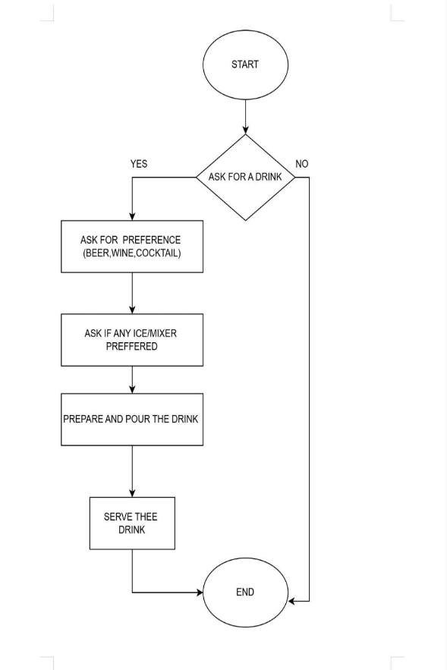
step-by-step process for serving a drink, ensuring consistency.
2. Customer Preference:
It asks for the customer's drink
preference and customization options
(ice/mixer), showing customer-centricity.
3. Simple and Clear: The flowchart is straightforward and easy to follow for basic drink serving.
4. Covers Basics: It covers essential steps like asking, preparing, and serving a drink.

Cons:
1. Limited Options: The flowchart only considers beer, wine, or cocktail preferences - it might not cover other drinks.
2. Lovers Special Handling: Doesn't account for special requests, allergies, or complex drink preparations.
3. No Payment Process: The flowchart doesn't include payment or handling money aspects.
4. Basic Error Handling: There's no path for handling issues like unavailability of a drink or customer changing their mind.
5. Simple End Point: The "END" is quite abrupt without considering customer satisfaction or further service.

